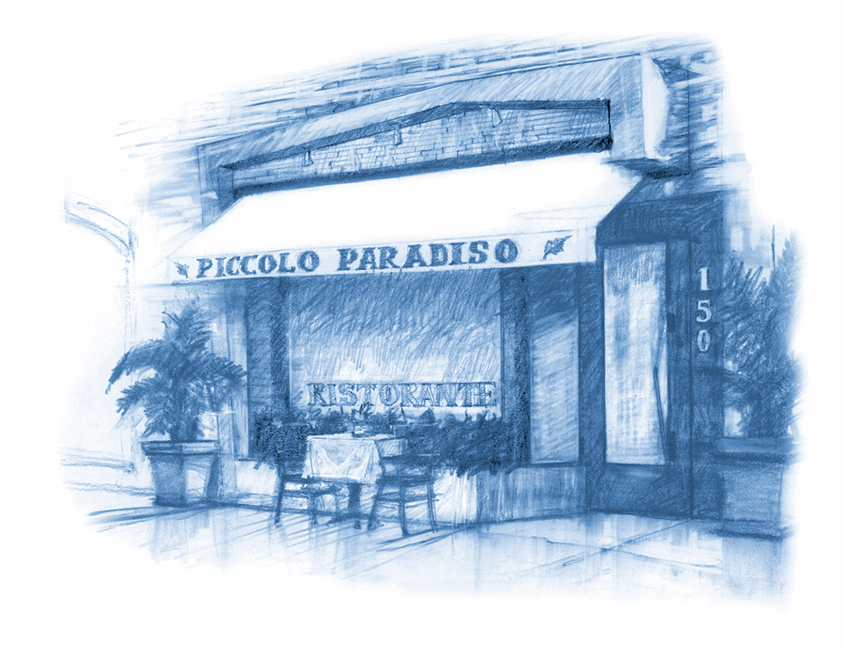
Dinner

Z u p p e e A n t i p a s t i

Cappelletti in Brodo

prosciutto stuffed tortellini, parmesan on chicken broth 16.50

Minestrone

fresh seasonal vegetable soup 9.95

Zuppetta di Cozze e Vongole

steamed mussels & clams in a light spicy tomato sauce 16.50

Melanzane alla parmiggiana

baked eggplant filled with ricotta, tomato, basil & mozzarella cheese 16.50

Calamari Fritti

crispy fried calamari, arrabbiata, tartar sauce 15.50

ADD SHRIMPS AND ZUCCHINI $6.00

Carciofi alla Romana

baked artichoke, mint & garlic broth 17.50

Carpaccio di manzo

beef carpaccio, capers, mustard, parmesan cheese 16.50

Bresaola

dried cured beef with arugula and pecorino cheese 16.50

Prosciutto San Daniele

thin sliced San Daniele prosciutto, port wine infused black figs,
gorgonzola cheese 16.50

Carpaccio di Tonno

ahi tuna carpaccio, baby frisée, tomato, onion, capers, lemon dressing 19.50

Burrata

creamy heart mozzarella cheese, roasted peppers 17.50

Polenta Soffice

corn meal polenta, porcini mushroom, truffle fondue 20.50

I n s a l a t e

Spinaci e pere

Baby Spinach, pear, caramelized walnuts, pecorino cheese, honey balsamic dressing 16.50

Cavolo Nero E Barbabietole

kale with onions, quinoa, cherry tomatoes and beets tartar 17.00

Piccolo Paradiso

arugula, fresh mozzarella, tomato, avocado, hearts of palm, shaved parmesan 16.50

Trevisana

chopped arugula, endive, radicchio, balsamic, parmesan 14.75

Carpaccio di Mele

thin sliced apple, endive, radicchio, gorgonzola cheese, walnuts 16.50

Panzanella

vine ripe tomatoes, cucumber, onion, toasted bread, olive oil 17.50

Cesare

classic caesar salad 14.00

Insalatina di campo

baby mixed greens, balsamic vinaigrette 9.50

Chopp Chopp

chopped romaine, green beans, canellini beans, onion, tuna on oil, lemon dressing 17.50

Insalata ai frutti di mare

steamed mussels, clams, calamari, shrimp, scallops, baby frisée,
parsley, garlic, olive oil, lemon dressing 21.50

Add: Chicken 5.50
Add: Shrimp 7.00 or Calamari 6.50

L e N o s t r e P a s t e C a s e r e c c i e
our selection of homemade pasta

Pappardelle | Strozzapreti | Tagliolini
Capellini | Rigatoni | Gnocchi
Fettuccine | Penne | Fusilli
Spaghetti | Linguine | Tagliatelle

Addiontal $3.50 with these pastas

Rice Pasta | Kamut | Spelt Pasta
Quinoa | Garganelli | Gluten Free Pasta

our own homemade sauces

Carbonara 20.50 | Amatriciana 19.50 | Pesto Genovese 20.00
Boscaiola 20.50 | Polpettine 19.50 | Frutti di Mare 25.50
Checca 15.50 | Arrabbiata 17.00 | Aglio e Olio 15.00
Natale 17.50 | Bolognese 18.50 | Montanara 30.50
Marinara 15.00

P a s t e R a v i o l i e r i s o t t i

Spaghetti Natale

latini spaghetti, baby san marzano tomatoes, basil 17.50

~ a favorite of Giacomino’s father ~

Spaghetti Cacio e Pepe

spaghetti with fresh black pepper sauce and pecorino 19.50

Tagliolini Verdi con Carciofi

Green tagliolini, baby artichoke, parmesan cheese 22.00

Paglia e Fieno

green & white tagliatelle, porcini mushroom sauce 23.50

Lasagnette al pesto

Small Lasagna Shape Pasta with Pesto Sauce 21.00

Cinghiale

pappardelle pasta, wild boar ragu 21.50

Fusilli Verdi con Cavolfiori

spinach fusilli, cauliflower, raisins, pine nuts, pecorino cheese 19.50

Spaghetti Alla Chitarra

homemade spaghetti pasta with sweet garlic tomato sauce 19.50

Rigatoni alla Siciliana

rigatoni, eggplant, mozzarella cheese, tomato sauce, basil 17.50

Garganelli Montanara

garganelli, morel mushrooms, sausage, black truffle, pecorino cheese 30.50

Gnocchi Paradiso

mushroom filled potato dumplings, truffle fondue 20.50

Linguine alle Vongole

linguine, fresh manila clams, lightly spicy white wine sauce 21.50

Linguine con Aragosta e Granchio

linguine, lobster, crab meat, lightly spicy tomato sauce 29.05

Ravioli di Spinach Ricotta

spinach & ricotta filled ravioli, tomato sauce 16.05

Ravioli di Vitello

veal filled Ravioli, porcini sauce 23.50

Raviolini di Burrata

green ravioli filled with burrata, porcini and truffle fondue sauce 25.50

Tortelli di Zucca

green tortelli filled with pumpkin, butter and sage sauce 19.50

Risotto di Donna Carmela

carnaroli rice, porcini mushroom 21.50

~ a tribute to Giacomino’s mother ~

Risotto Veneziana

carnaroli rice, squid ink, calamari, shrimp and clams 25.50

C a r n e e P e s c e

Paillard di pollo con Vegetali

grilled pounded chicken breast, vegetables, mashed potato 22.95

Ossobuco

veal shank, soft polenta, vegetables 31.50

Tagliata di Bue

grilled new york strip, thinly sliced and drizzled with an aromatic herb sauce 31.50

Braciola di Vitello

grilled rack of veal, rosemary sauce, mashed potato, vegetables 37.95

Saltibocca di Vitello

pounded veal, sage, parma prosciutto, bel paese cheese 31.50

Scaloppine di Vitello con Porcini

veal medallion, porcini mushroom sauce, mashed potato, vegetables 31.50

Filetto Al Barolo e Gorgonzola

fillet mignon on barolo wine sauce and gorgonzola cheese with roasted potatoes and spinach 37.95

Scaloppine di pollo

chicken piccata, mashed potato, vegetable 25.95

Milanese di Vitello

breaded & pounded rack of veal, arugula, chopped tomato 38.95

Salmone alla Griglia

salmon, with spelt, porcini mushroom, quinoa and Grean beans 27.50

Agnello con Porcini al Balsamico
Roasted Rack of Lamb with Porcini Crust served with Roasted Baby Carrots and Green Beans 39.95

C h e f ’ s T a s t i n g M e n u

Five Course Tasting Menu

two person minimum 70

plate splitting charge 4.00

