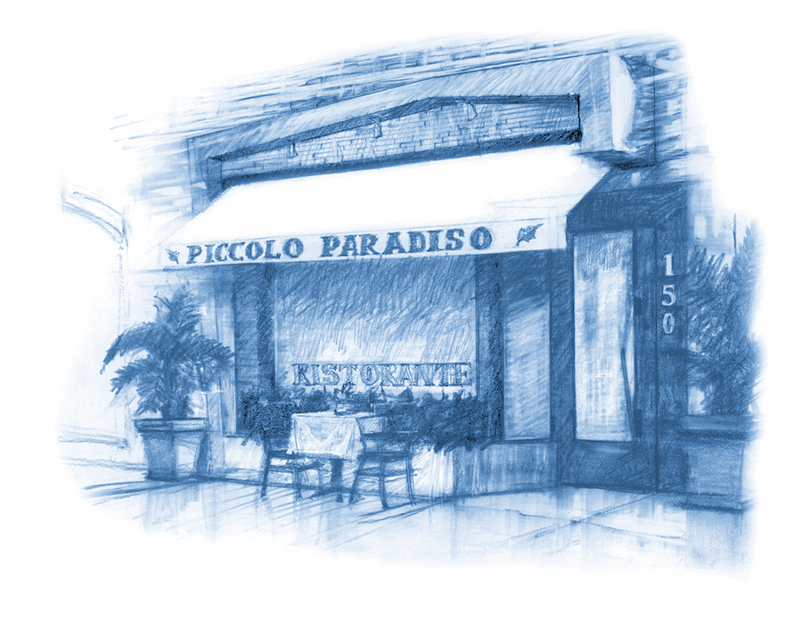
Lunch

Z u p p e e A n t i p a s t i

Cappelletti in Brodo

prosciutto stuffed tortellini, parmesan on chicken broth 15.50

Minestrone

fresh seasonal vegetable soup 9.50

Zuppetta di Cozze e Vongole

steamed mussels & clams in a light spicy tomato sauce 14.50

Melanzane alla parmiggiana

baked eggplant filled with ricotta, tomato, basil & mozzarella cheese 14.50

Calamari Fritti

crispy fried calamari, arrabbiata, tartar sauce 14.50

ADD SHRIMPS AND ZUCCHINI $6.00

Carciofi alla Romana

baked artichoke, mint & garlic broth 16.50

Carpaccio di manzo

beef carpaccio, capers, mustard, parmesan cheese 15.50

Bresaola

dried cured beef with arugula and pecorino cheese 15.50

Prosciutto San Daniele

thin sliced San Daniele prosciutto, port wine infused black figs,
gorgonzola cheese 15.50

Carpaccio di Tonno

ahi tuna carpaccio, baby frisée, tomato, onion, capers, lemon dressing 18.50

Burrata

creamy heart mozzarella cheese, roasted peppers 16.50

Polenta Soffice

corn meal polenta, porcini mushroom, truffle fondue 19.50

I n s a l a t e

Spinaci e pere

Baby Spinach, pear, caramelized walnuts, pecorino cheese, honey balsamic dressing 15.50

Cavolo Nero e barbabietole

kale with onions, quinoa, cherry tomatoes and beets tartar 15.50

Piccolo Paradiso

arugula, fresh mozzarella, tomato, avocado, hearts of palm, shaved parmesan 15.50

Trevisana

chopped arugula, endive, radicchio, balsamic, parmesan 14.00

Carpaccio di Mele

thin sliced apple, endive, radicchio, gorgonzola cheese, walnuts 15.50

Panzanella

vine ripe tomatoes, cucumber, onion, toasted bread, olive oil 16.50

Cesare

classic caesar salad 13.00

Insalatina di campo

baby mixed greens, balsamic vinaigrette 8.50

Chopp Chopp

chopped romaine, green beans, canellini beans, onion, tuna on oil, lemon dressing 16.50

Insalata ai frutti di mare

steamed mussels, clams, calamari, shrimp, scallops, baby frisée,
parsley, garlic, olive oil, lemon dressing 20.50

Add: Chicken 5.50
Add: Shrimp 7.00 or Calamari 6.50

L e N o s t r e P a s t e C a s e r e c c i e
our selection of homemade pasta

Pappardelle | Strozzapreti | Tagliolini
Capellini | Rigatoni | Gnocchi
Fettuccine | Penne | Fusilli
Spaghetti | Linguine | Tagliatelle

Addiontal $3.50 with these pastas

Rice Pasta | Kamut | Spelt Pasta
Quinoa | Garganelli | Gluten Free Pasta

our own home made sauces

Carbonara 19.50 | Amatriciana 18.50 | Pesto Genovese 19.50
Boscaiola 19.50 | Polpettine 18.50 | Frutti di Mare 24.50
Checca 14.50 | Arrabbiata 16.00 | Aglio e Olio 14.00
Natale 16.50 | Bolognese 18.50 | Montanara 29.50
Marinara 14.00

P a s t e R a v i o l i e r i s o t t i

Spaghetti Natale

latini spaghetti, baby san marzano tomatoes, basil 16.50

~ a favorite of Giacomino’s father ~

Spaghetti Cacio e Pepe

spaghetti with fresh black pepper sauce and pecorino 18.50

Tagliolini Verdi con Carciofi

Green tagliolini, baby artichoke, parmesan cheese 21.00

Paglia e Fieno

green & white tagliatelle, porcini mushroom sauce 22.50

Lasagnette al pesto

Small Lasagna Shape Pasta with Pesto Sauce 20.00

Cinghiale

pappardelle pasta, wild boar ragu 20.50

Fusilli Verdi con Cavolfiori

spinach fusilli, cauliflower, raisins, pine nuts, pecorino cheese 18.50

Spaghetti alla chitarra

homemade spaghetti pasta with sweet garlic tomato sauce 18.50

Rigatoni alla Siciliana

rigatoni, eggplant, mozzarella cheese, tomato sauce, basil 16.50

Garganelli Montanara

garganelli, morel mushrooms, sausage, black truffle, pecorino cheese 29.50

Gnocchi Paradiso

mushroom filled potato dumplings, truffle fondue 19.50

Linguine alle Vongole

linguine, fresh manila clams, lightly spicy white wine sauce 20.50

Linguine con Aragosta e Granchio

linguine, lobster, crab meat, lightly spicy tomato sauce 28.05

Ravioli di Spinach Ricotta

spinach & ricotta filled ravioli, tomato sauce 15.00

Ravioli di Vitello

veal filled Ravioli, porcini sauce 22.50

Raviolini di Burrata

green ravioli filled with burrata, porcini and truffle fondue sauce 24.50

Tortelli di Zucca

Green tortelli filled with pumpkin, butter and sage sauce 18.50

Risotto di Donna Carmela

carnaroli rice, porcini mushroom 20.50

~ a tribute to Giacomino’s mother ~

Risotto Veneziana

carnaroli rice, squid ink, calamari, shrimp and clams 24.50

C a r n e e P e s c e

Paillard di pollo con Vegetali

grilled pounded chicken breast, vegetables, mashed potato 21.95

Ossobuco

veal shank, soft polenta, vegetables 29.95

Tagliata di Bue

grilled new york strip, thinly sliced and drizzled with an aromatic herb sauce 29.50

Braciola di Vitello

grilled rack of veal, rosemary sauce, mashed potato, vegetables 35.50

Saltibocca di Vitello

pounded veal, sage, parma prosciutto, bel paese cheese 29.95

Scaloppine di Vitello con Porcini

veal medallion, porcini mushroom sauce, mashed potato, vegetables 29.95

Filetto al Barolo e gorgonzola

fillet mignon on barolo wine sauce and gorgonzola cheese with roasted potatoes and spinach 36.95

Scaloppine di pollo

chicken piccata, mashed potato, vegetable 24.50

Milanese di Vitello

breaded & pounded rack of veal, arugula, chopped tomato 38.95

Salmone alla Griglia

salmon, with spelt, porcini mushroom, quinoa and Grean beans 26.50

Agnello con Porcini al Balsamico
Roasted Rack of Lamb with Porcini Crust served with Roasted Baby Carrots and Green Beans 37.95

C h e f ’ s T a s t i n g M e n u

Five Course Tasting Menu

two person minimum 70

plate splitting charge 4.00

